7.2.32 Editors - 3D View - Header - Grease Pencil - Weight Paint Mode - Weights Menu
Weight Paint Mode - Weights Menu 2
Normalize All 2
Last Operator Normalize all Vertex Group 2
Lock Active 2
Normalize 2
Invert 2
Smooth 2
Last Operator Smooth Vertex Group 2
Factor 2
Iterations 2
Generate Weights 2
With empty Groups 3
With automatic Weights 3
Last Operator Generate Automatic Weights 3
Mode 3
Armature 3
Ratio 3
Decay 3
Brush Radius 3
Brush Strength 3

Weight Paint Mode - Weights Menu

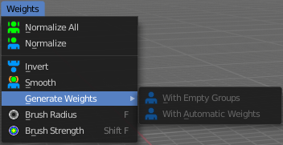

Normalize All
Normalizes the weight of all Vertex groups so that the values for the single vertices in the sum is 1.

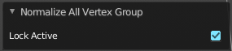
Last Operator Normalize all Vertex Group

Lock Active
Keep the values of the active group while normalizing others.

Normalize
Normalize normalizes the weight of the current selected Vertex group so that the values for the single vertices in the sum is 1. Means when there is influence from other groups, then those values are kept, but the one for the current group gets lowered so that the sum is 1.

Invert
Invert inverts the weight painting for the selected vertex group.

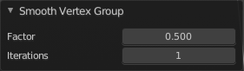
Smooth
Smooths the weight for selected vertices.

Last Operator Smooth Vertex Group

Factor
Here you adjust the factor.

Iterations
Here you adjust how many iterations you use.

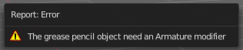
Generate Weights
The menu items are greyed out as long as there is no weight painting at the grease pencil stroke. And you need to have the grease pencil stroke parented to an armature. Or you will get an error.

With empty Groups
Parents the vertices to the bones, but with empty vertex groups.

With automatic Weights
Parents the vertices to the bones, but tries to apply automatic weighting, based at the envelope weight of the bones.

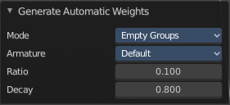
Last Operator Generate Automatic Weights

Mode
With empty groups or with automatic weights.

Armature
Which armature to use. There can be more than one armature in the hierarchy.

Ratio
The ratio between bone lenght and influence radius. This adjusts the envelope weight of the bones.

Decay
Factor to reduce influence depending of distance to bone axis. This adjusts the envelope weight of the bones.

Brush Radius
Adjust the brush radius by hotkey. Hotkey only tool! The menu entry just exists to tell you that the functionality is available.

Brush Strength
Adjust the brush strength by hotkey. Hotkey only tool! The menu entry just exists to tell you that the functionality is available.

